**Project Documentation**

**FITFLEX: YOUR PERSONAL FITNESS COMPANION**

**1. Introduction**

• **Project Title: Fitflex: Your Personal Fitness Companion**

• **Website Title : FITFLEX**

• **Team ID:** NM2025TMID37845

• **Team Leader:** S. Jesna , Mail Id:[jesnajesna2707@gmail.com](mailto:jesnajesna2707@gmail.com)

**Team Members:**

– R. Afrin Nisha, Mail Id:[nisharnnishu@gmail.com](mailto:nisharnnishu@gmail.com)

-M. Keerthika, Mail Id:[keerthiambi2005@gmail.com](mailto:keerthiambi2005@gmail.com)

-K. Krithika, Mail Id:[krithikavaishu683@gmail.com](mailto:krithikavaishu683@gmail.com)

-G. Monika, Mail Id:[monimonika0914@gmail.com](mailto:monimonika0914@gmail.com)

**2. Project Overview**

• **Purpose:** Fitflex is designed to help individuals stay motivated,track progress, and achieve their fitness goals. It acts as a personal companion by offering customized workout plans, nutrition guidance, progress tracking, and real-time motivation–making fitness simple, engaging, and accessible anytime, anywhere.

• **Features:**

Personalized workout plans.

Smart reminders & motivation.

Easy and simple user interface to use.

Has a search engine to search various Exercises..

**3. Architecture**

• **Frontend:** React.js with Bootstrap and Material UI

• **Backend:** Node.js and Express.js managing server logic and API endpoints

• **Database:** MongoDB stores user data, project information, applications, and chat .

**4. Setup Instructions**

• **Prerequisites:**

Node.js

MongoDB

Git

React.js

Express.js **–** Mongoose **–** Visual Studio Code

• **Installation Steps:**

# Clone the repository git clone

# Install client dependencies cd

client npm install

# Install server dependencies cd

../server npm install

**5. Folder Structure**

SB-Works/

|-- client/ # React frontend

| components/ L

pages/

| server/ # Node.js backend

| routes/

| models/

| controllers/

**6. Running the Application**

Front end

Cd client npm start

Backend

Cd server npm start

● **Access:** Visit: http://localhost:3000/

**7. API Documentation**

**1. FITFLEX**

/api/home/ fitflex: your personal fitness companion/

**2. EXERCISES**

**/api/exercises/**

/api/most popular categories/back/

**3. SEARCH WORKOUTS**

/api/hme/search bar/search/selected bodyparts/selected equipments

**8.Authentication**

• JWT-based authentication for secure login

• Middleware protects private routes

**User Interface**

• Landing Page with popular categories of fitness.

• Fitness Dashboard.

• Search engine bar at the top right corner of the page to search various exercises.

**Testing**

• Manual testing during milestones

• Tools: Postman for API testing, chrome Dev Tools for frontend testing.

**Screenshots or Demo**

Demo link:

<https://drive.google.com/file/d/1HW7M2U-W8jbEASozkQnB_8xdorcz_iCr/view?usp=drive_link>

HOME PAGE:

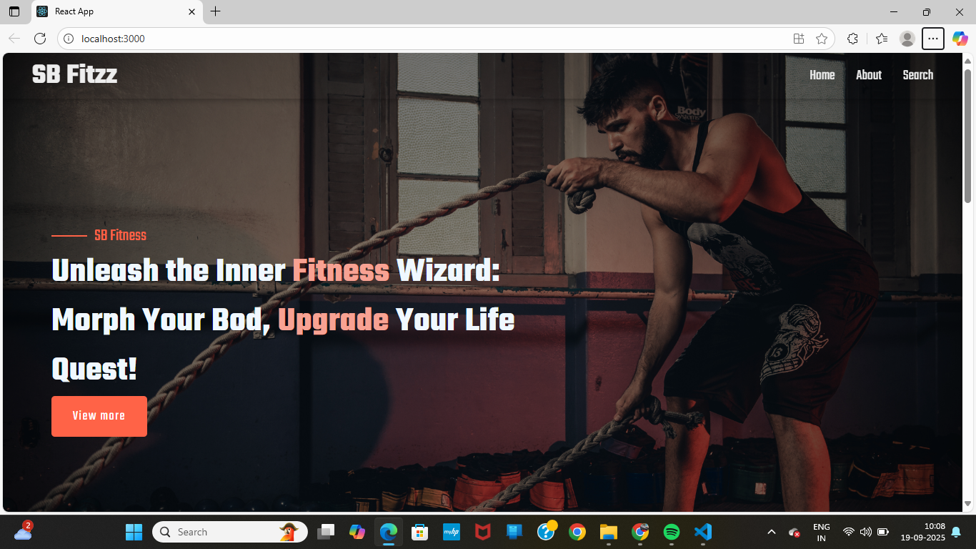

ABOUT PAGE: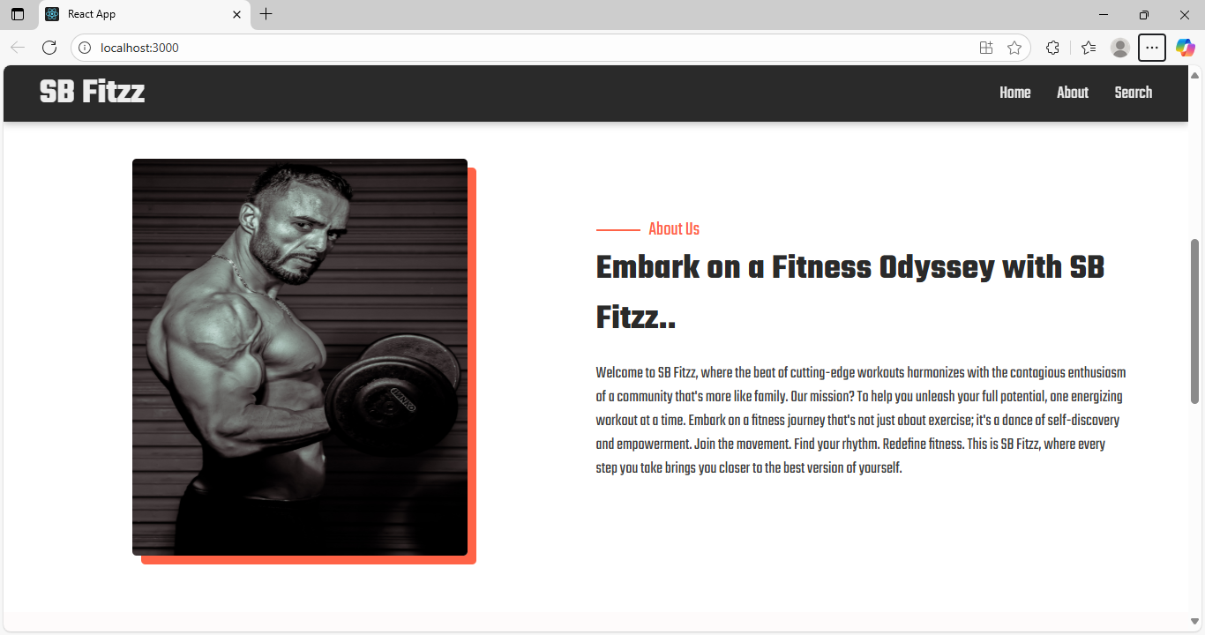

SEARCH PAGE:

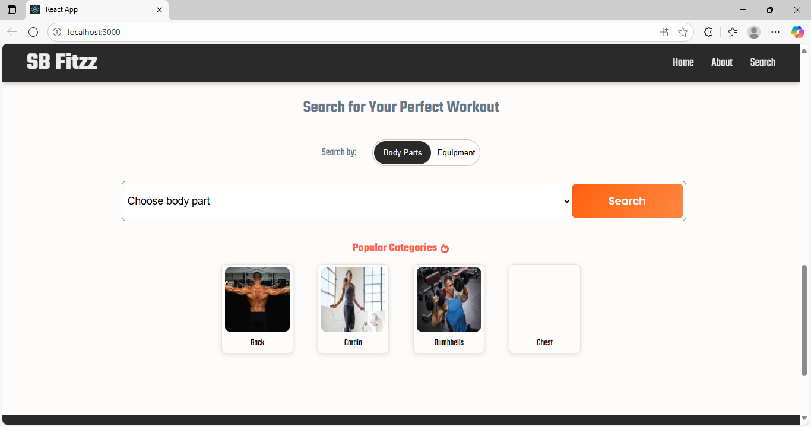

**Known Issues**

NIL

**Future Enhancements**

● AI powered Virtual Coach- A Conversational fitness assistant that gives real time feedback on your workouts.

● AR Workout Mode-Augmented reality-based exercise guidance to make workouts interactive and engaging.

● Advanced Body Composition Analysis-Use of smart devices to track fat %, muscle mass, and hydration levels more accurately.